Costa Rican Bulk Rock Compositions

Julie M. Coulombe

4/1/2020

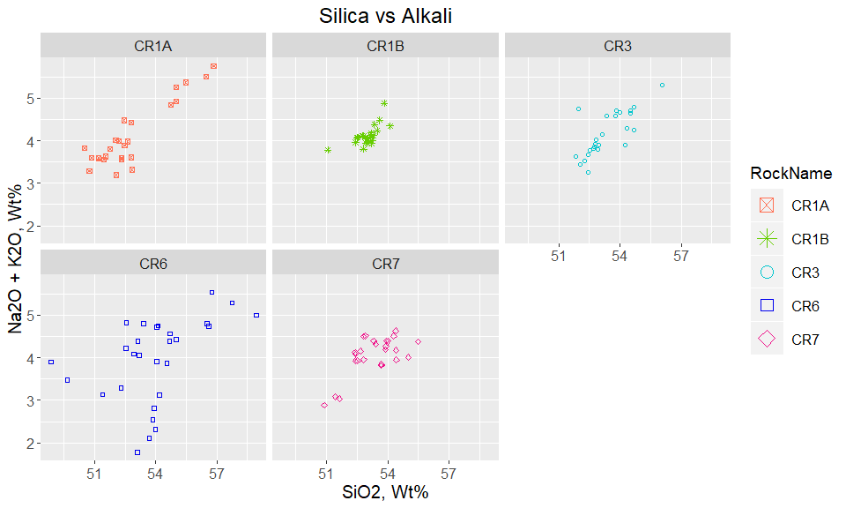

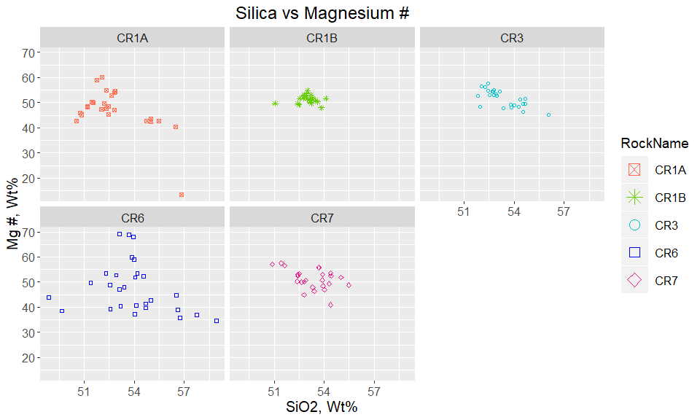

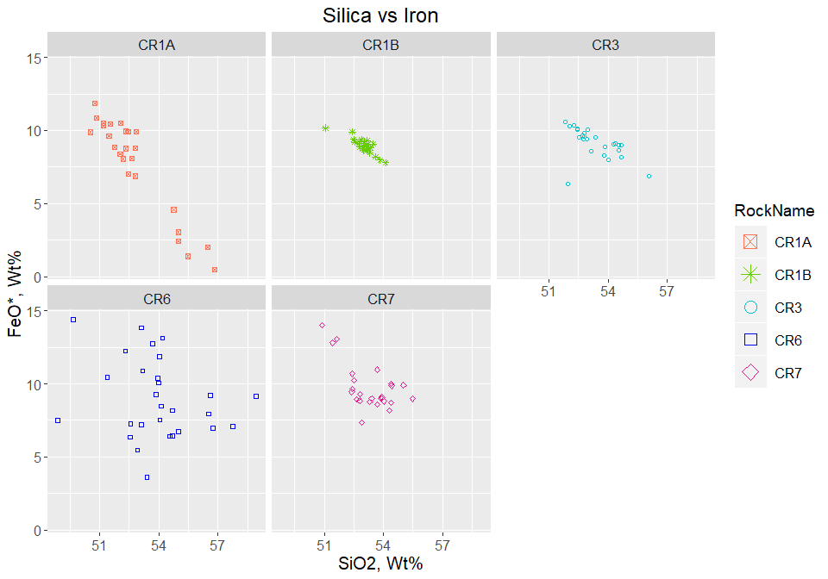

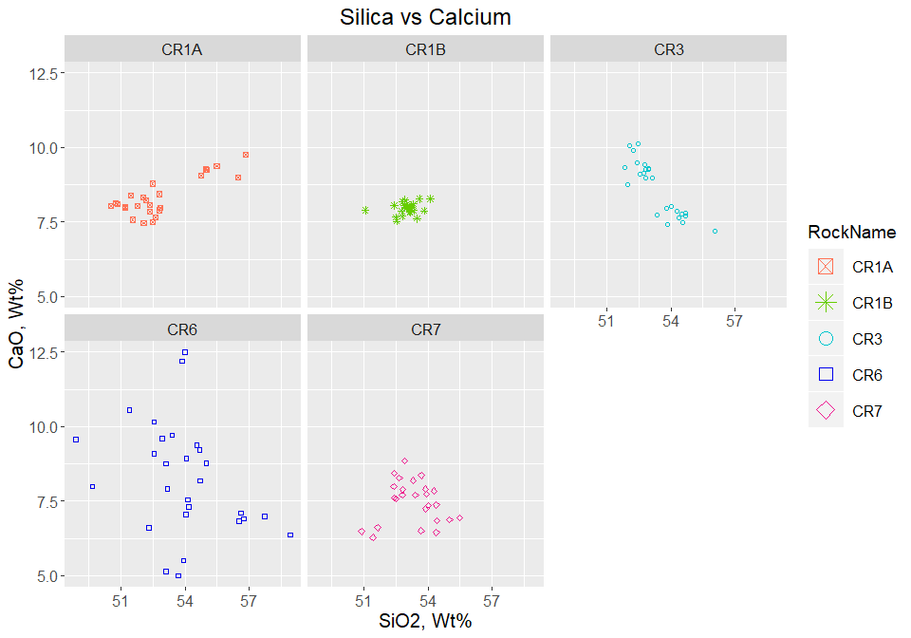

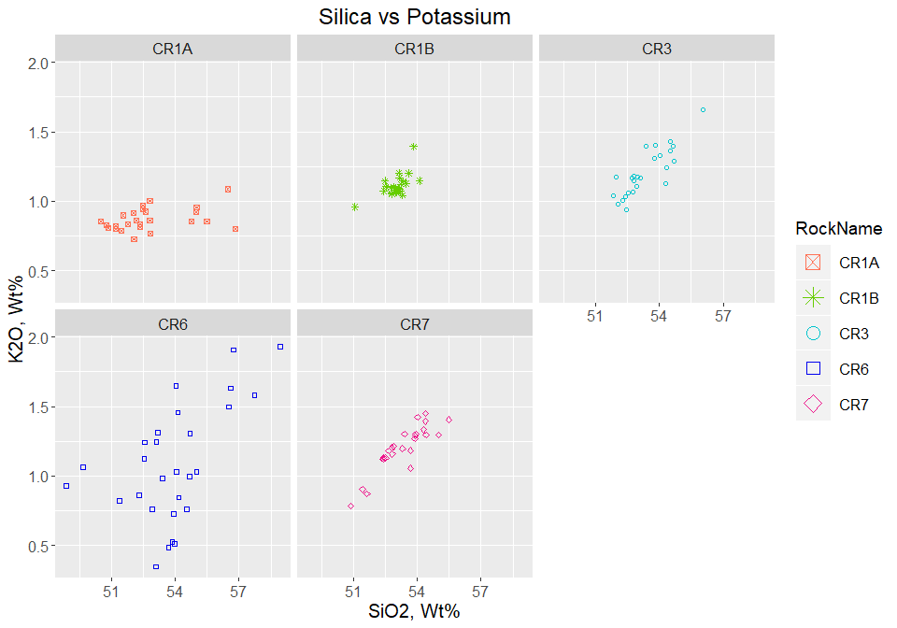

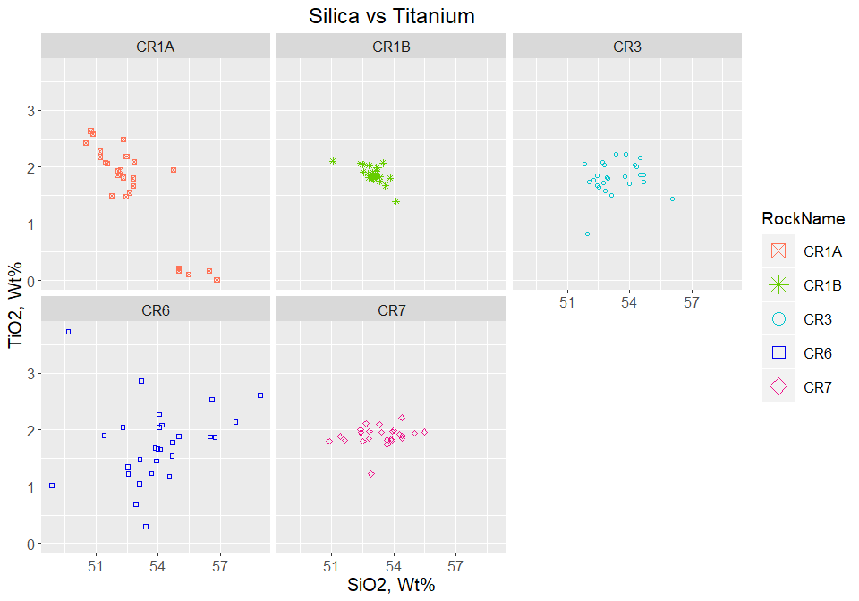

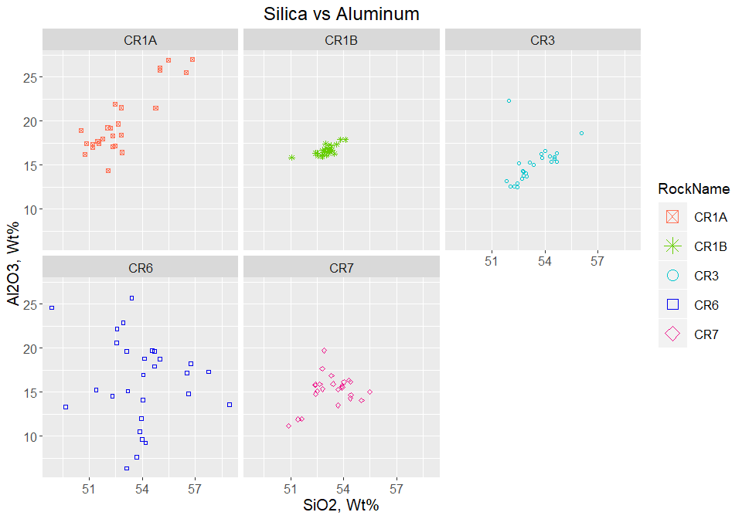

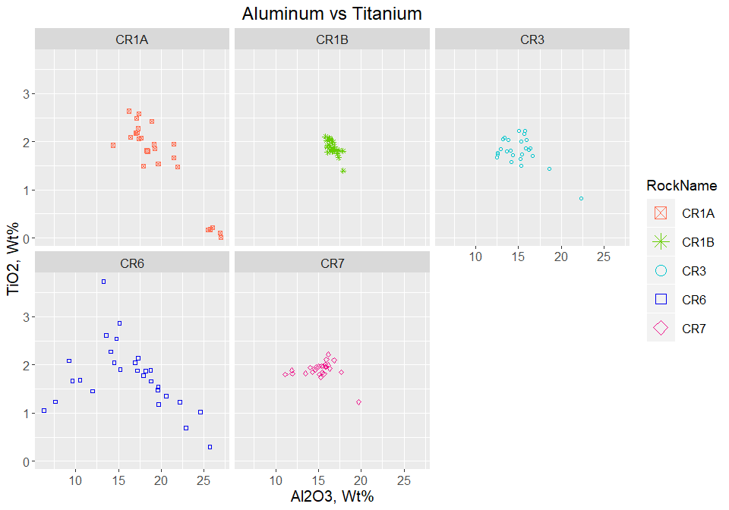

Plot Alkali by Rock Name - Bulk Composition 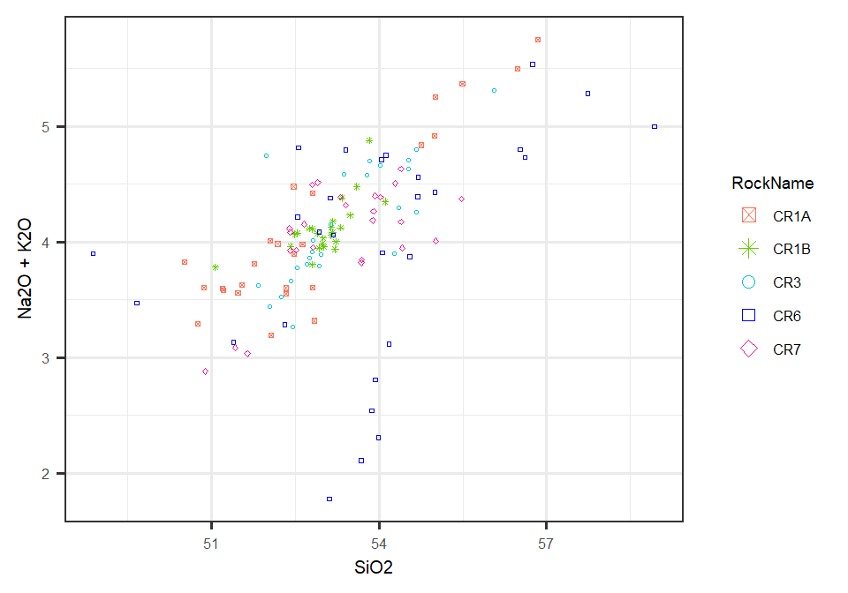

Overlay Alkali Plot on TAS Diagram 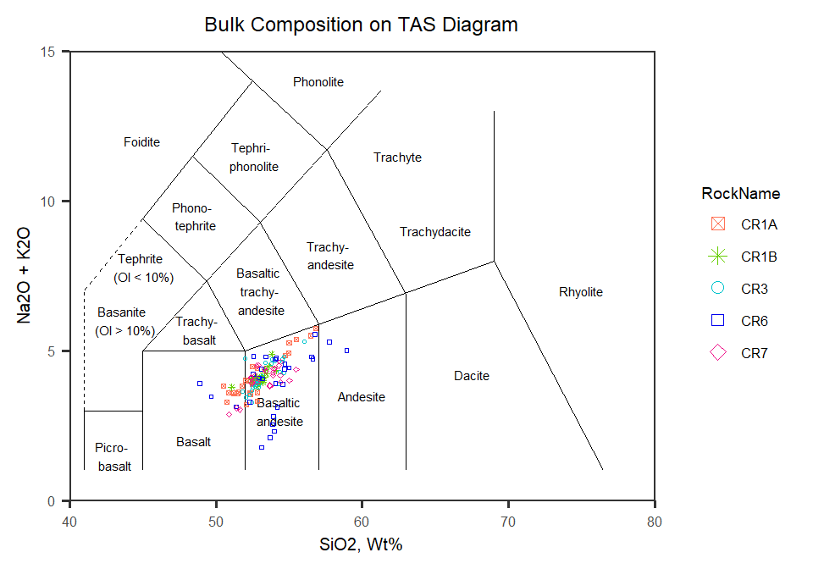

Now to look at plots of all rocks together

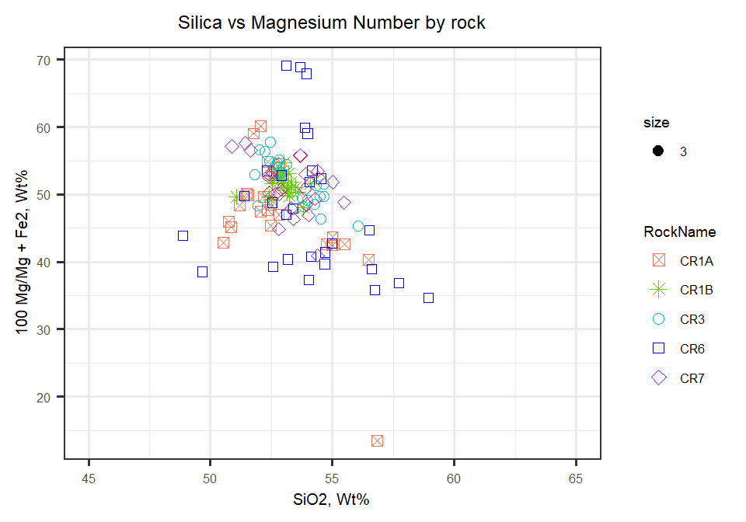

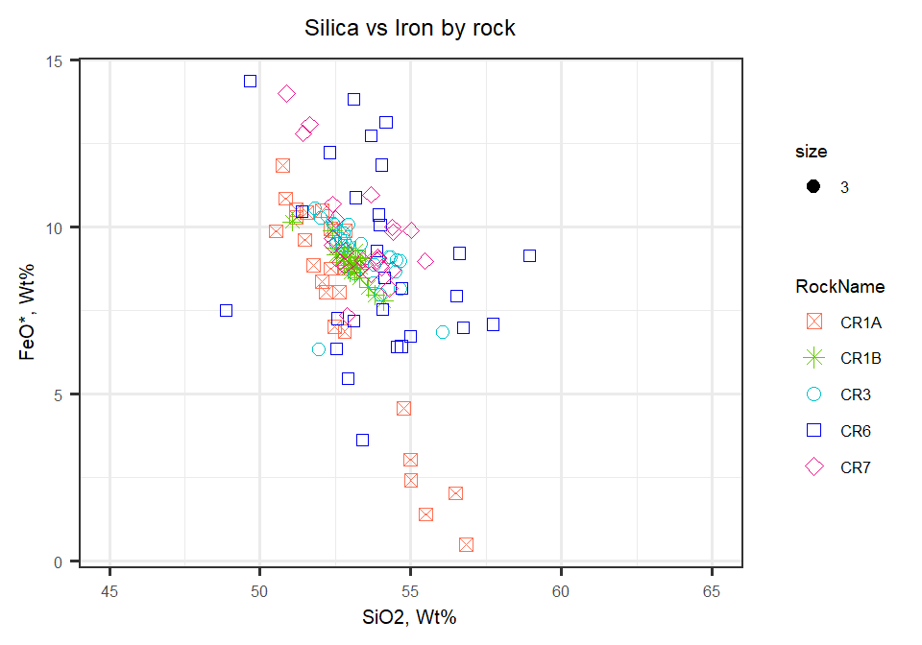

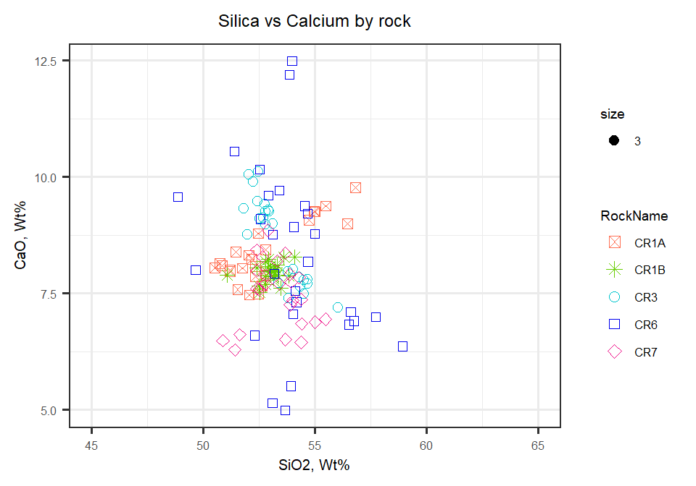

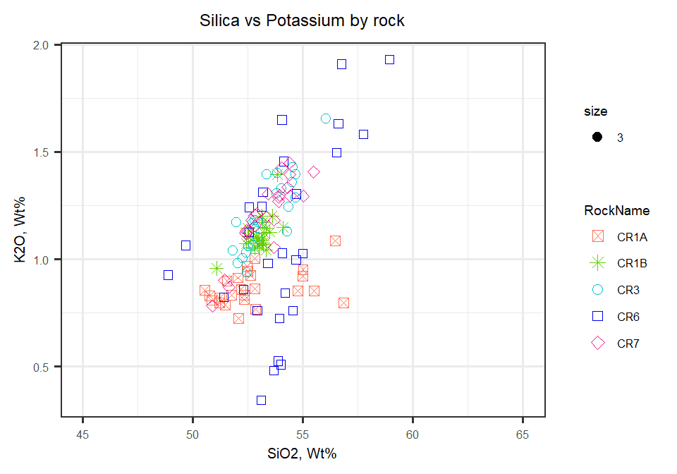

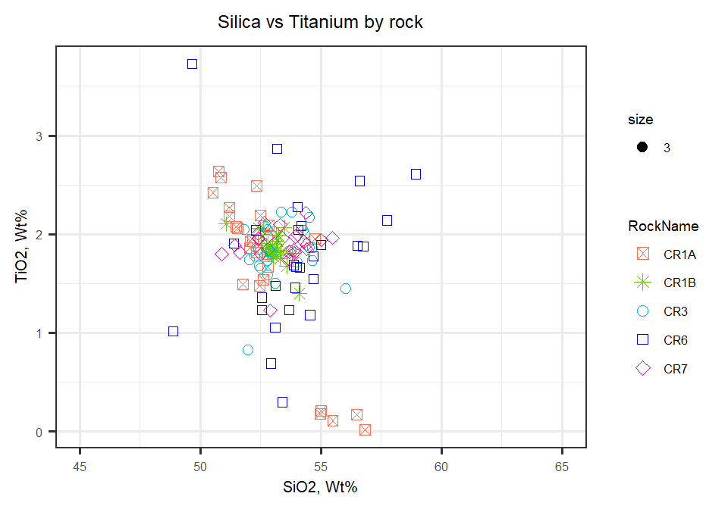

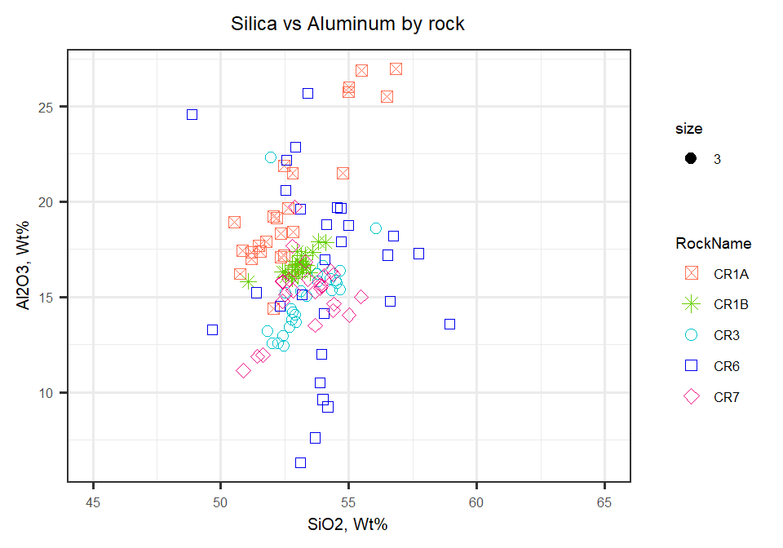

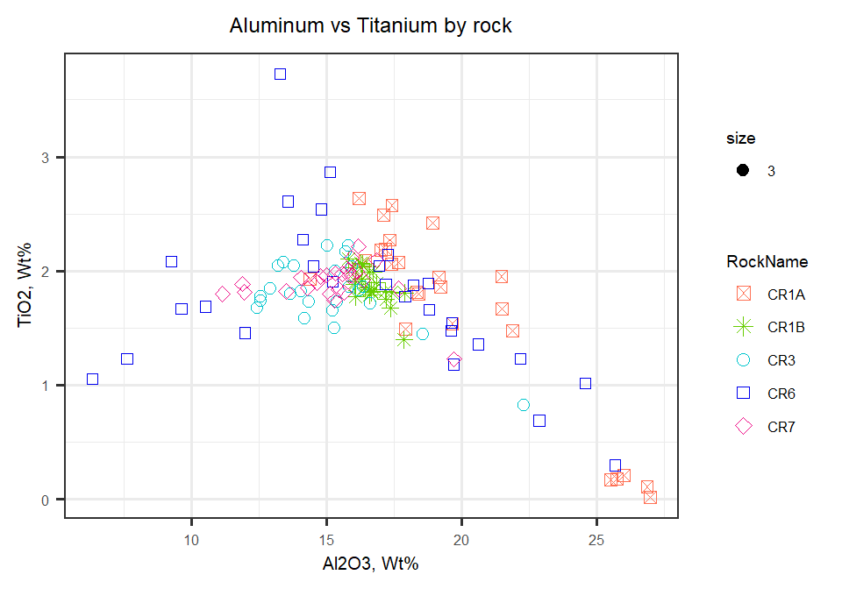

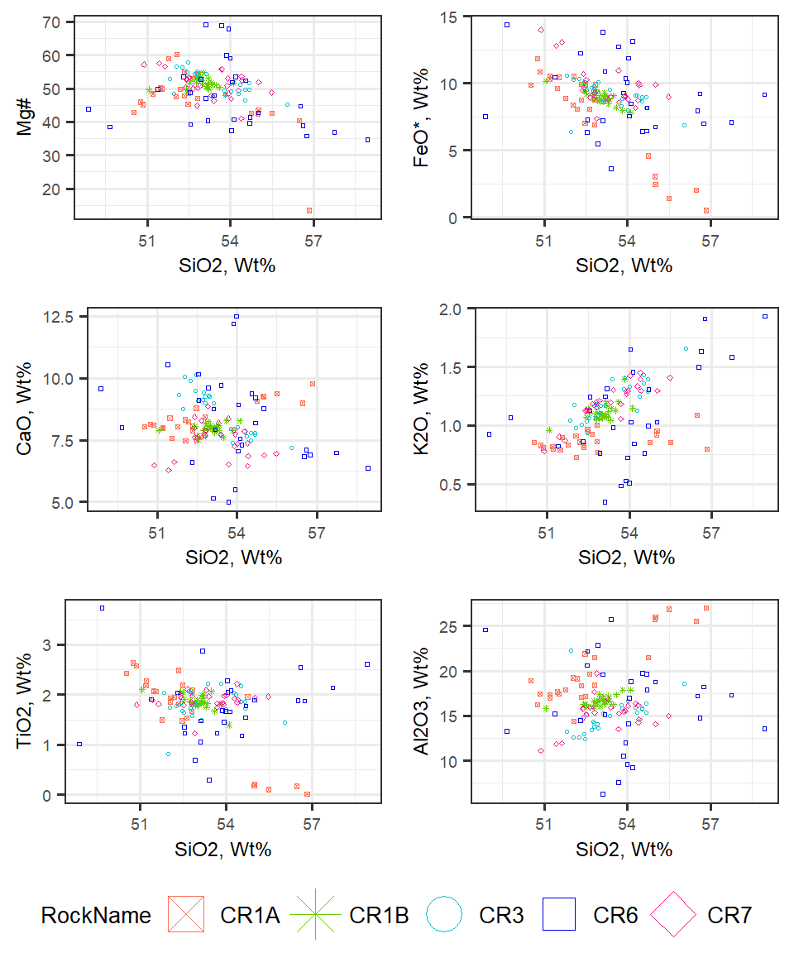

Figure 2: Major elements plotted against SiO2. All Wt% except Mg#

Now to compare CR1A to CR1B Harker Diagrams  
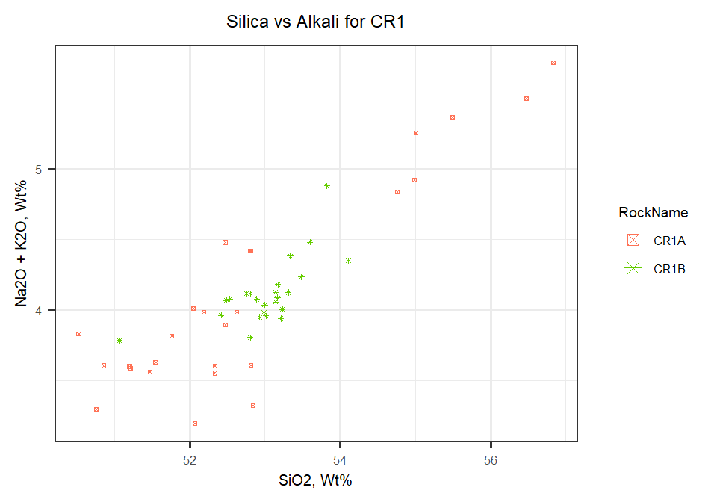

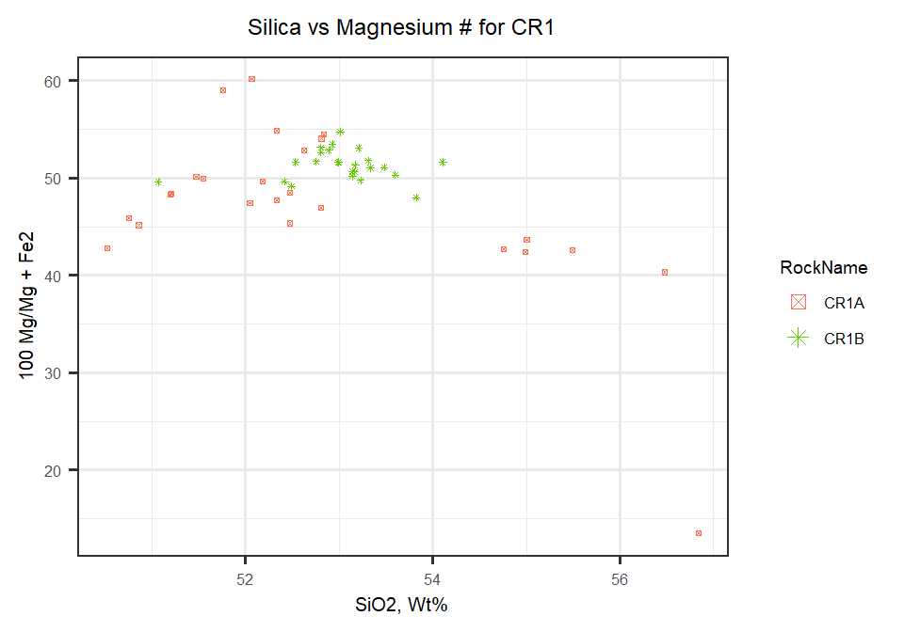

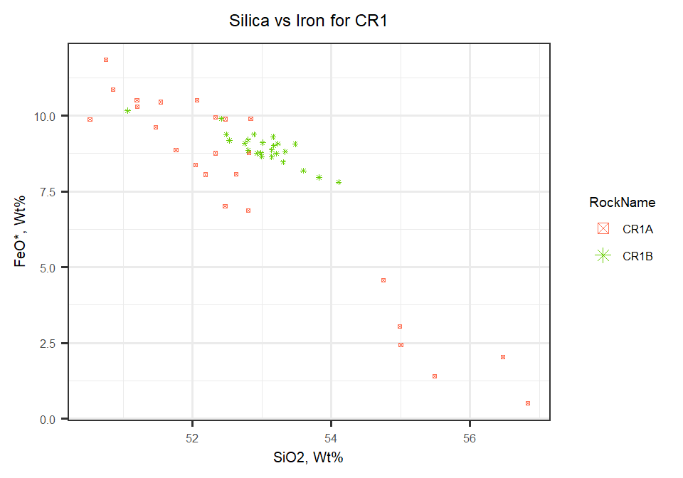

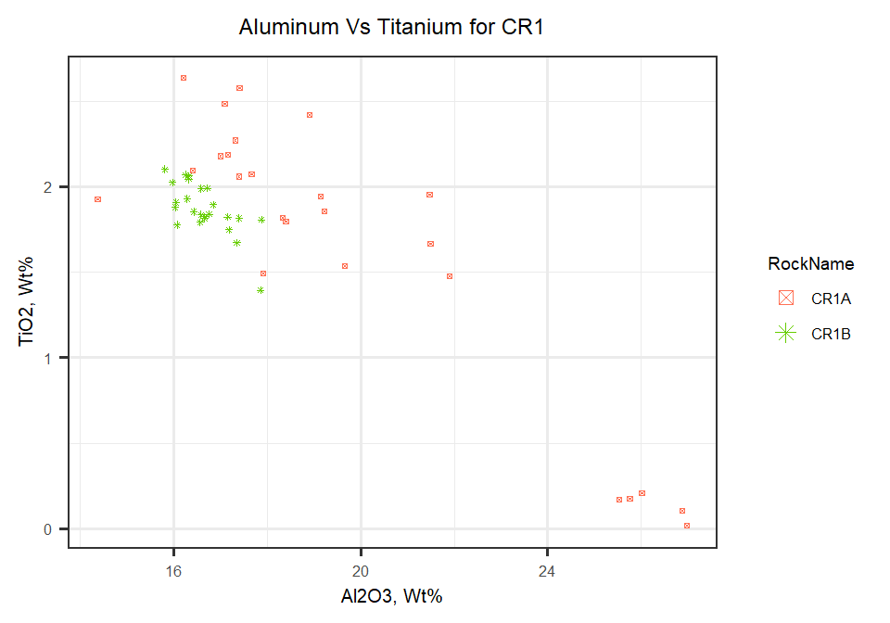

Taking a look at comparing CR2A to CR2B in Bulk Composition (bulk data for CR2 not yet available)

Table indicating mean averages for elements by rock

|  |  |  |  |  |  |
| --- | --- | --- | --- | --- | --- |
| **Element** | **CR1A** | **CR1B** | **CR3** | **CR6** | **CR7** |
| SiO2 | 52.8 | 53 | 53.3 | 53.9 | 53.3 |
| TiO2 | 1.64 | 1.87 | 1.81 | 1.76 | 1.9 |
| Al2O3 | 19.8 | 16.7 | 15.1 | 16.3 | 15.2 |
| Cr | 0.0311 | 0.0264 | 0.0285 | 0.0322 | 0.0261 |
| MgO | 4.32 | 5.29 | 5.59 | 5.33 | 5.88 |
| CaO | 8.33 | 7.95 | 8.62 | 8.24 | 7.48 |
| MnO | 0.11 | 0.147 | 0.162 | 0.158 | 0.168 |
| Fe2O3 | 7.7 | 8.93 | 9.12 | 8.95 | 9.73 |
| Na2O | 3.24 | 3 | 2.95 | 2.87 | 2.86 |
| K2O | 0.868 | 1.11 | 1.21 | 1.09 | 1.2 |
| S | 0.00635 | 0.00881 | 0.00736 | 0.00902 | 0.00784 |
| P2O5 | 0.302 | 0.349 | 0.346 | 0.301 | 0.349 |
| Total | 99.3 | 98.8 | 98.9 | 99.1 | 98.8 |